PXO: Poly-XTAL operations V10.00. Free MATLAB codebase to generate and analyse complex 2D poly-crystalline grain structures

**INTRODUCTION AND FUNCTIONALITITES**

Sunil Anandatheertha1

1PhD student, Faculty of Engineering and Computing, Coventry University, Coventry CV1 5FB, UK

**Author contributions**

|  |  |
| --- | --- |
| Sunil Anandatheertha | Conceptualization, Software development and maintenance, documentation and manuscript preparation |

**Table of Contents**

1.1. Highlights 2

1.2. Abstract 3

1.3. Background and motivation 3

1.4. Functionalities 4

1.5. Capabilities 4

1.6. Applications 5

1.7. Available workflow paths for materials scientists 5

1.8. Theory, pseudo-code and implementation 6

1.8.1. Q-state Pott’s model 6

1.8.2. Boundary condition 7

1.9. Kernel weight functions 8

1.10. Functionalities and capabilities for grain structure analysis in Poly-XTAL Operations 10

1.10.1. Grain segregation 10

1.10.2. Making 2nd phase particles 11

1.10.3. Making grain structures for CPFEM using Poly-XTAL Operations 12

1.11. Functionalities and capabilities enabled by 3rd party MATLAB libraries 12

1.11.1. Analysing Poly-XTAL Operations generated grain structure in MTEX 12

1.11.2. Making grain structures for CPFEM using mtex2gmsh 13

1.12. References 13

1.13. Appendix-A: Gallery 14

**Table of figures**

Figure 1: Numbering conventions used on the square lattice for theory and implementation 6

Figure 2: Illustration of boundary condition (a) rectangular grid (b) toroidal boundary condition with torsion $τη=0$ and $τζ=0$ (c) toroidal boundary condition with $τη=π2$ and $τζ=0$ 7

Figure 3: Boundary conditions (a) Peripheral type (b) Internal type 8

Figure 4: Example values of Kernel weight function parameters 9

Figure 5: Visualization of the Kernel weight matrix elements $Wij$ (a-i) and temporal slices of grain structure at Tsim. = 500 and 1000 evolved by using $Wij$ 10

Figure 6: (a, b) State wise partitioned number of grains at Tsim. = 500 and 1000 respectively (c & d) statistics of the number of grains at Tsim. = 500 and 1000 (e, f) grain size statistics at Tsim. = 500 and 1000 (g) temporal evolution of number of grains 11

Figure 8: Types of 2nd phase particles which can be made: (a) Straight and thin nanotubes/needles, (b) Wavy and thin nanotubes, (c) Straight and thick nanotubes, (d) Wavy and thick nanotubes, (e) Nanotubes, Single lattice site particles and dense lattice site particle clusters and (f) Nanotubes, Single lattice site particles and single lattice site particle clusters 11

Figure 7: Grain structure exchange between Poly-XTAL Operations 9.04 and MTEX 5.04 (a) Poly-XTAL Operations (b) Grain boundary mis-orientations calculated using MTEX (c) MTEX calculated grain shape distribution for the grain structure made in Poly-XTAL Operations 9.04 12

Figure 9: (a) Grain structure in Poly-XTAL Operations (b) Region inside the grain structure (c and d) Triangular and Quadrilateral mesh for the highlighted region in the grain structure, made using mtex2gmsh routine called from MTEX 5.04 13

Figure 10: Few example temporal slices of partitioned space having a maximum of 2 unique states. 14

Figure 11: Few example temporal slices of partitioned space having a maximum of 32 unique states 15

## Highlights

* Free MATLAB codebase for researchers working on computational materials science, computational geology, dynamics of importance sampling Monte-Carlo schemes and graphenes.
* Make spatiotemporally gradient 2D grain structures and associate spatiotemporally gradient crystallographic texture to the grain structure
* Export ABAQUS input file for use in CPFEM
* Work with Ising model and Q-state Pott’s model simulation on square lattices
* Call MTEX libraries and mtex2gmsh

## Grain structures

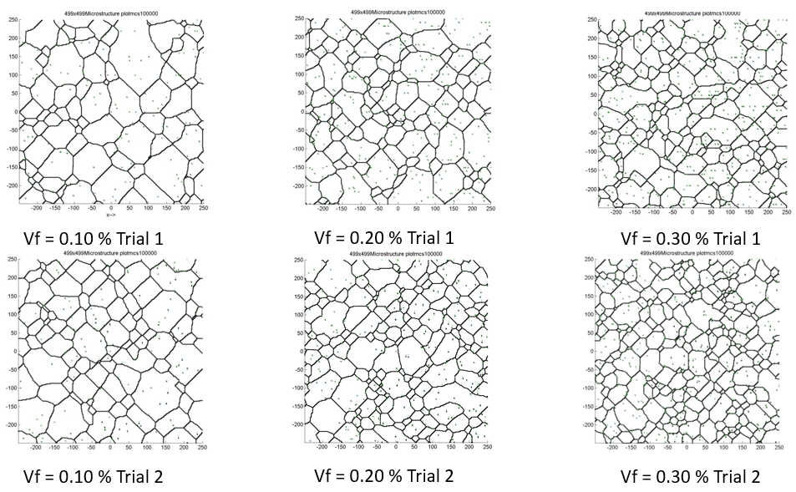

Figure 1:

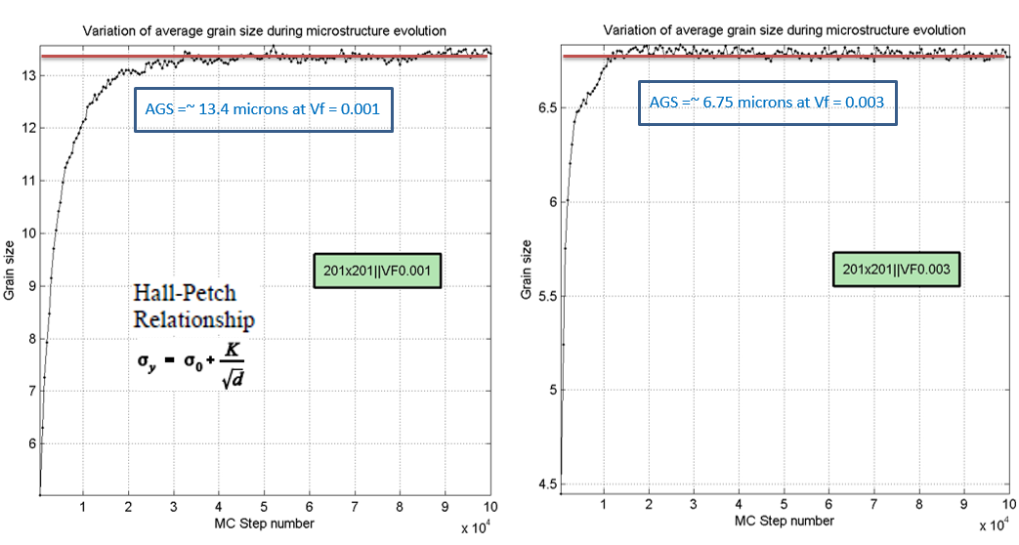

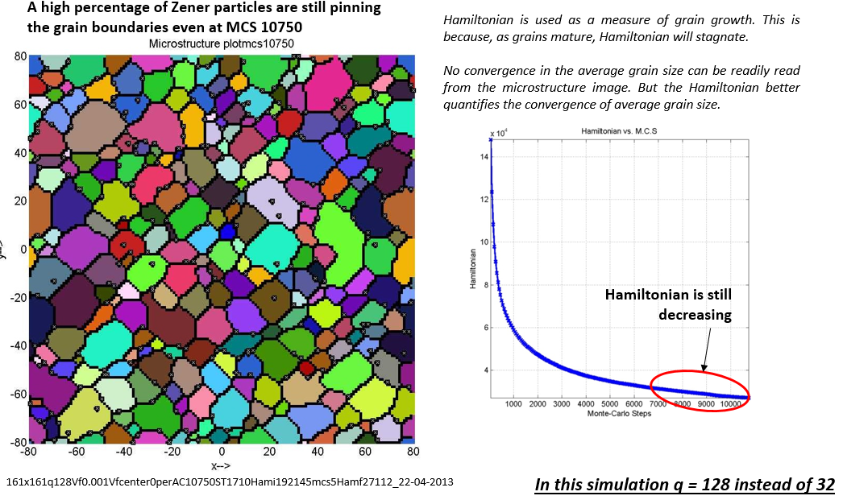

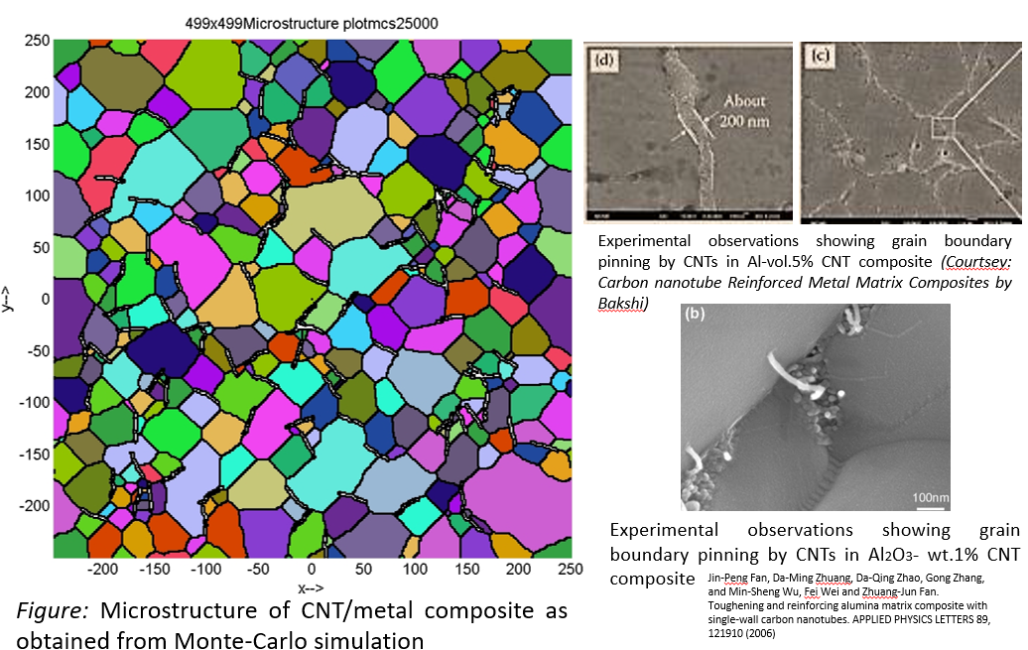

Experimental observations showing grain boundary pinning by CNTs in Al-vol.5% CNT composite *(Courtsey: Carbon nanotube Reinforced Metal Matrix Composites by Bakshi)*

*Experimental observations showing grain boundary pinning by CNTs in Al2O3- wt.1% CNT composite*

Jin-Peng Fan, Da-Ming Zhuang, Da-Qing Zhao, Gong Zhang, and Min-Sheng Wu, Fei Wei and Zhuang-Jun Fan. Toughening and reinforcing alumina matrix composite with single-wall carbon nanotubes. APPLIED PHYSICS LETTERS 89, 121910 (2006)

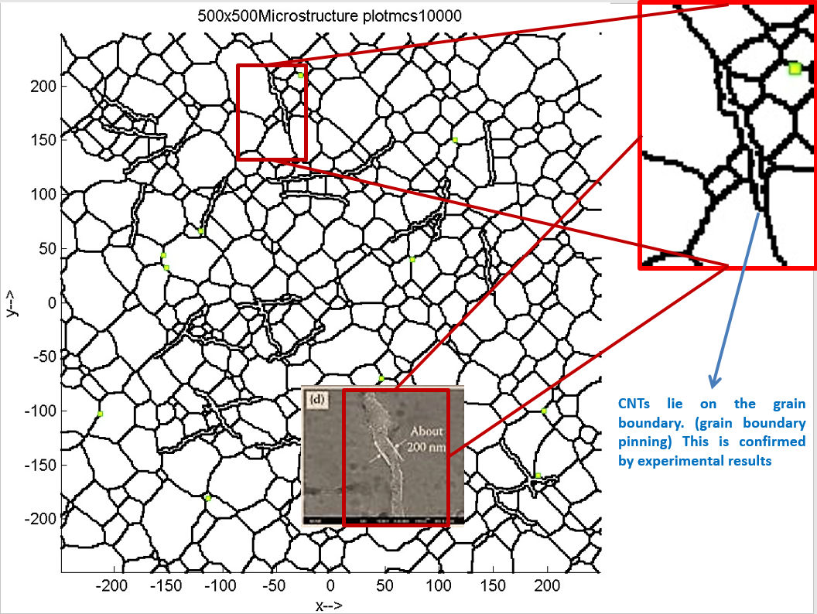

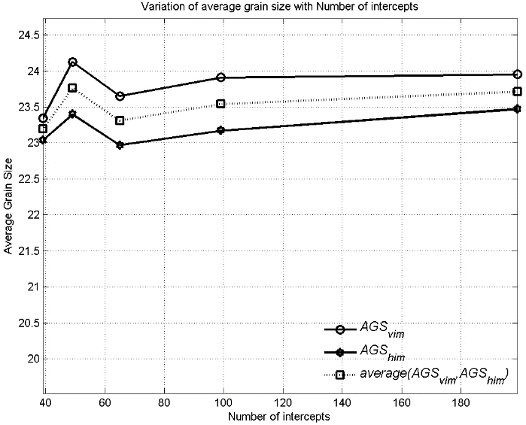

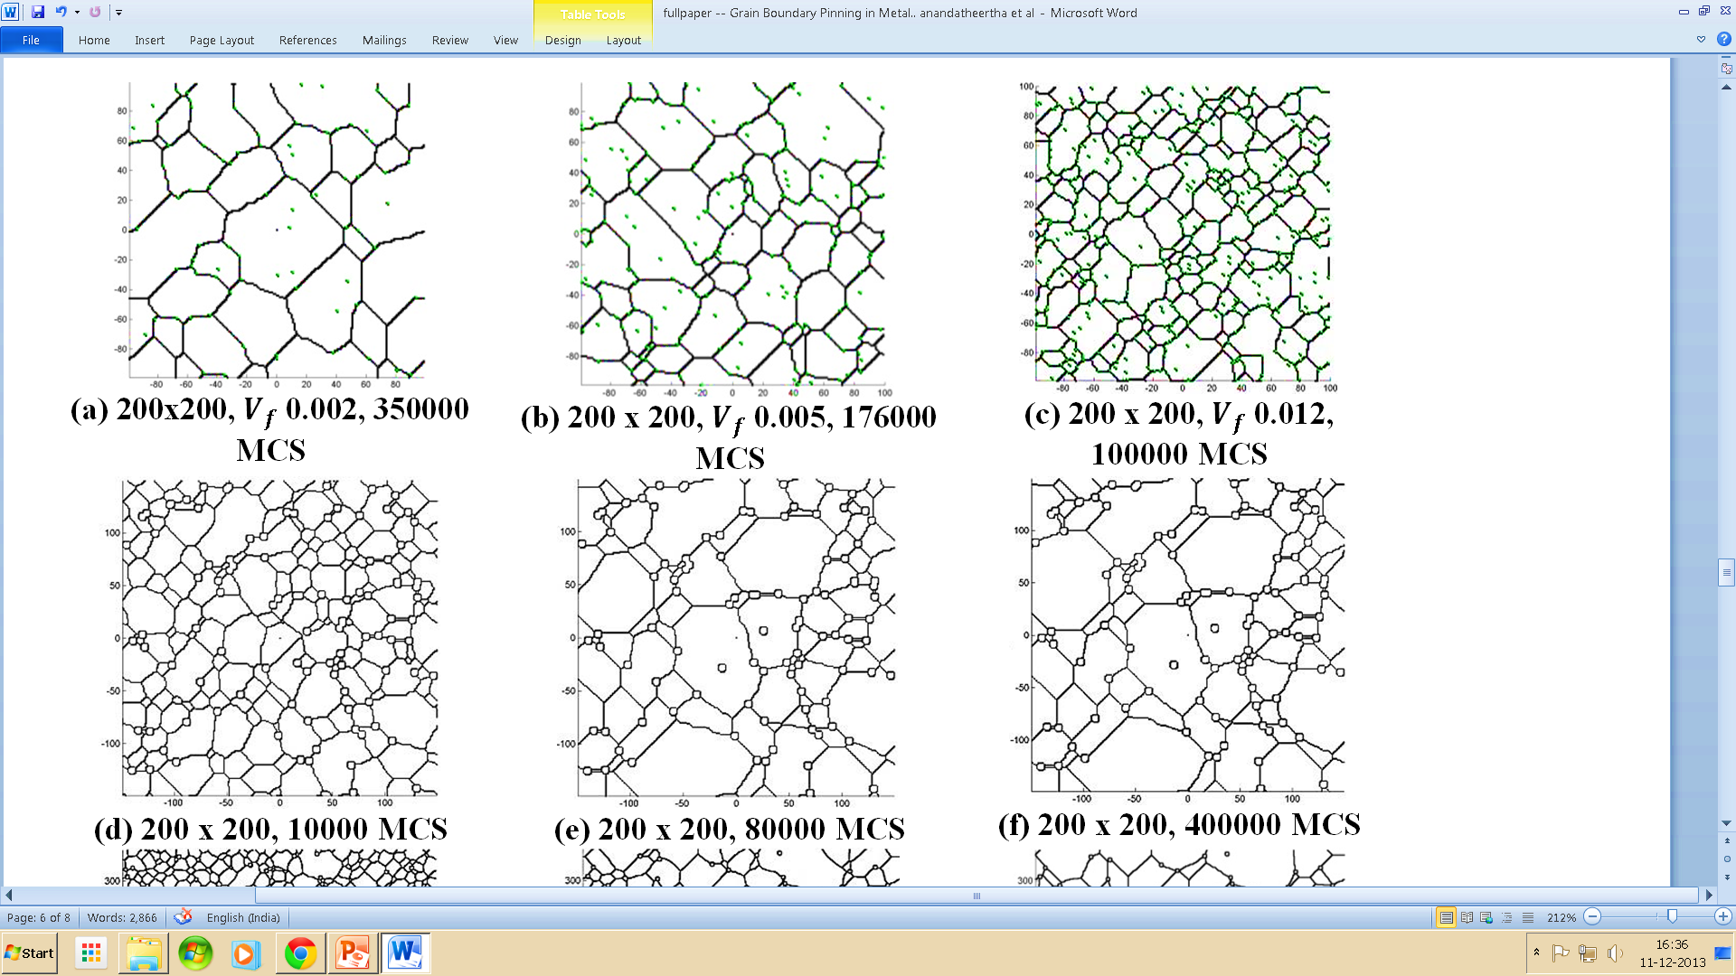

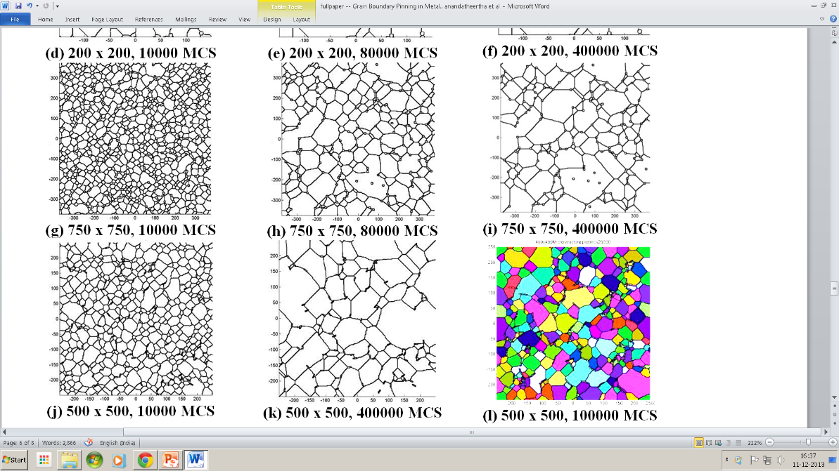

## Kernel function parameters for POTTS grain structures

Refer “*PXO_test_cases-POTTS_Kernels_V1.0.xlxs*” for values and the corresponding grain structure snapshots that are produced.

## References

[1] R.J. Baxter, Exactly Solved Model in Statistical Mechanics, Academic press, Harcourt Brace Jovanovich, 1989.

[2] D. Weaire, S. Mcmurry, Some Fundamentals of Grain Growth, Solid State Phys. - Adv. Res. Appl. 50 (1996) 1–36. https://doi.org/10.1016/S0081-1947(08)60603-7.

[3] M.P. Anderson, D.J. Srolovitz, G.S. Grest, P.S. Sahni, Computer simulation of grain growth-I. Kinetics, Acta Metall. 32 (1984) 783–791. https://doi.org/10.1016/0001-6160(84)90151-2.

[4] M.P. Anderson, G.S. Grest, R.D. Doherty, K. Li, D.J. Srolovitz, Inhibition of grain growth by second phase particles: Three dimensional Monte Carlo computer simulations, Scr. Metall. 23 (1989) 753–758. https://doi.org/10.1016/0036-9748(89)90525-5.

[5] D.J. Srolovitz, M.P. Anderson, G.S. Grest, P.S. Sahni, Computer simulation of grain growth-III. Influence of a particle dispersion, Acta Metall. 32 (1984) 1429–1438. https://doi.org/10.1016/0001-6160(84)90089-0.

[6] P.A. Manohar, M. Ferry, T. Chandra, Five Decades of the Zener Equation, ISIJ Int. 38 (1998) 913–924. https://doi.org/10.2355/isijinternational.38.913.

[7] W.B. Li, K.E. Easterling, The influence of particle shape on zener drag, Acta Metall. Mater. 38 (1990) 1045–1052. https://doi.org/10.1016/0956-7151(90)90177-I.

[8] F. Roters, P. Eisenlohr, L. Hantcherli, D.D. Tjahjanto, T.R. Bieler, D. Raabe, Overview of constitutive laws, kinematics, homogenization and multiscale methods in crystal plasticity finite-element modeling: Theory, experiments, applications, Acta Mater. 58 (2010) 1152–1211. https://doi.org/10.1016/j.actamat.2009.10.058.

[9] F. Bachmann, R. Hielscher, H. Schaeben, Texture analysis with MTEX- Free and open source software toolbox, Solid State Phenom. 160 (2010) 63–68. https://doi.org/10.4028/www.scientific.net/SSP.160.63.

[10] F. Bachmann, R. Hielscher, H. Schaeben, Grain detection from 2d and 3d EBSD data-Specification of the MTEX algorithm, Ultramicroscopy. 111 (2011) 1720–1733. https://doi.org/10.1016/j.ultramic.2011.08.002.